Software Version: | V1.02.03
Published Date: | 2014/12/31

Content:
Revision History: 2
New Features: 2
Problems Fixed 3
Known Issues: 3
Related Documentation 3

Revision History:

Software Version | Date | Model | Hardware Version
V1.02.03 | 2014/12/31 | DNR-312L | A1

System Requirement (minimum HW requirement)

Hardware Requirements

System Minimum Requirements
One 3.5” SATA hard disk drive

Network Requirements Broadband Internet connection (for remote access)

Network camera(s) (refer to the D-Link website for a list of supported cameras)

Web-based Configuration Utility

Requirements/Remote PC

Minimum Requirements
10/100/1000 Mbit Ethernet switch or router Computer with the following:

Computer with Microsoft Windows 7, 8, Vista, or XP (with Service Pack 3); Mac OS X (10.7 or above)
PC with Pentium 4 – 2.4 GHz or above; at least 512MB RAM Internet Explorer 7, Firefox 12, Chrome 20, or Safari 4 or higher. Existing 10/100/1000 Ethernet-based network

New Features:

Software  Version | New Features
V1.02.03 | - ONVIF support (Profile S V14.06)  - Support Device Pack  - Add Recycle setting include keep days and HDD % space  - Support D-Link Discovery Protocol  - Ability to turn on/off camera motion detection and adjust sensitivity and percentage through DNR-312L local & remote GUI  - Support 720P option for HDMI output  - Support snapshot in playback  - Remove SSL 3.0  - Support Cameras: DCS-930LB1 / DCS-932LB1 / DCS-942LB1 / DCS-3714  /DCS-5615 / DCS-6004L /DCS-6005L / DCS-6112B1 / DCS-6113B1 / DCS-6115 / DCS-6314 / DCS-6315 / DCS-7000L / DCS-7110B1 / DCS-7413B1/ DCS-2210L / DCS-2230L

Problems Fixed:

Software Problems Fixed

Version
V1.02.03 | - Fixed issue with privileges users  - Fixed issue with HDD page  - Fixed DLAB DBG14040657: After DUT optimized cameras, DCS-7110 video  settings wouldn't be changed.  - Fixed DLAB DBG14080392: A non-admin account couldn't browse the Playback page.  - Fixed DLAB DBG14080396: Display and Language page would be disappeared after log-in by a non-admin account.

Known Issues:

Firmware  Version | Known Issues
V1.02.03 | 1.Video Clip can’t export on browser of the MAC O.S.  Root cause: MAC O.S. don’t have Microsoft AVI library, so it can’t export AVI in MAC O.S.

Related Documentation:

N/A

Note:

Software Version: | V1.01.05
Published Date: | 2014/08/08

Content:
Revision History: 2
New Features: 2
Problems Fixed 3
Known Issues: 3
Related Documentation 3

Revision History:

Software Version | Date | Model | Hardware Version
V1.01.05 | 2014/08/08 | DNR-312L | A1

System Requirement (minimum HW requirement)

Hardware Requirements

System Minimum Requirements
One 3.5” SATA hard disk drive

Network Requirements Broadband Internet connection (for remote access)

Network camera(s) (refer to the D-Link website for a list of supported cameras)

Web-based Configuration Utility

Requirements/Remote PC

Minimum Requirements
10/100/1000 Mbit Ethernet switch or router Computer with the following:

Computer with Microsoft Windows 7, 8, Vista, or XP (with Service Pack 3); Mac OS X (10.7 or above)
PC with Pentium 4 – 2.4 GHz or above; at least 512MB RAM Internet Explorer 7, Firefox 12, Chrome 20, or Safari 4 or higher. Existing 10/100/1000 Ethernet-based network

New Features:

Software  Version | New Features
V1.01.05 | - Upgrade the mydlink agent 2.0.18-b07  - Support Bonjour function  - Support Japanese language  - Support SNMP function  - Support manually add IP camera device  - Change "Glace" tip to "Auto Scan"  - Support NVR event CGI  - Modify Speed/ Zoom / Focus speed control CGI  - Support auto hide function.  - Support snapshot button on live view  - Support new setup wizard on local GUI  - Support network port setting  - Schedule  - Support schedule recording setting by drop & drag (2)Change "Record on normal" button to "continuous recording"  - Playback  - Change “Video Export:” tip to “Video Export: Please select first, the

Cue-in and Cue-out points in order to export”
(2) Support new Help content
- Change Default value of all event settings
- Change E-map display by sheet on live view

Problems Fixed:

Software  Version | Problems Fixed
V1.01.05 | - Fixed the SAMBA test won’t create the test file  - Fixed LED display to red color when it meets HDD erro  - Fixed sometimes there no audio in playback  - Popup messages to alert user when enable manual record and there is no any setting in schedule recording  - Support 6TB HDD  - Rename "Super Model" to "Universal Model"  - Fixed the camera list sequence on camera model list  - Disable manual record after NVR reset  - display mydlink agent version on firmware upgrade page  13. Fixed DLAB DBG14040657 : After DUT optimized cameras, DCS-7110 video settings wouldn't be changed.  - Fixed DLAB DBG14030330: DCS-942L microphone volume would be changed to 0 when DUT optimized cameras.  - Fixed DLAB DBG14030329: DCS-5222L microphone volume would be changed to 0 when DUT optimized cameras.  - Fixed DLAB DBG14050174: No warning message when set an incorrect password of the dlinkddns.  - Fixed DLAB DBG14050252: Some converted video clips would be in flip mode unexpectedly  - Fixed DLAB DBG14050165: DUT couldn't format a WD Enterprise 2 TB HDD  - Fixed DLAB DBG14050222: E-map might be abnormal after some steps  - Fixed DLAB DBG14050184: A single IP couldn't be setup to the allowed list  - Fixed DLAB DBG14050185: A single IP couldn't be setup to the blocked list  - Fixed DLAB DBG14050221: No test file would be uploaded to a SMB server after click the "Test" icon in Auto Backup settings page  - Fixed DLAB DBG14030316: DUT couldn't be inserted a record by other cameras event/motion as help instruction.  - Fixed DLAB DBG14030358: Playback and backup information is incomplete in the Help page.  - Fixed DLAB DBG14030359: Remote login DUT on a Mac by Safari would show error rather than camera live video.

Known Issues:

Firmware Known Issues

Version
V1.01.05 | 1.Video Clip can’t export on browser of the MAC O.S.  Root cause: MAC O.S. don’t have Microsoft AVI library, so it can’t export AVI in MAC O.S.

Related Documentation:

N/A

Note:

Software Version: | V1.00.45
Published Date: | 2014/08/01

Content:
Revision History: 2
New Features: 2
Problems Fixed 3
Known Issues: 3
Related Documentation 3

Revision History:

Software Version | Date | Model | Hardware Version
V1.00.45 | 2014/08/01 | DNR-312L | A1

System Requirement (minimum HW requirement)

Hardware Requirements

System Minimum Requirements
One 3.5” SATA hard disk drive

Network Requirements Broadband Internet connection (for remote access)

Network camera(s) (refer to the D-Link website for a list of supported cameras)

Web-based Configuration Utility

Requirements/Remote PC

Minimum Requirements
10/100/1000 Mbit Ethernet switch or router Computer with the following:

Computer with Microsoft Windows 7, 8, Vista, or XP (with Service Pack 3); Mac OS X (10.7 or above)
PC with Pentium 4 – 2.4 GHz or above; at least 512MB RAM Internet Explorer 7, Firefox 12, Chrome 20, or Safari 4 or higher. Existing 10/100/1000 Ethernet-based network

New Features:

Software  Version | New Features
V1.00.45 | It’s first MP version.

Problems Fixed:

Software  Version | Problems Fixed
V1.00.45 | N/A

Known Issues:

Firmware  Version | Known Issues
V1.00.45 | - Safari 7 will not work on MAC 10.9.  - Audio codec cannot support AAC-11K  - Video export from local site – it cannot supports OSD display & only support

AVI format
- If DNR-312L and IP camera are located at different LAN and WAN, it might needs to open 80 port and 554 port in NAT setting for transmitting video and audio streaming.
- Video export issue, please refer to the page 4 for getting more detail information.
- DNR-312L only supports 1080P resolution with HDMI V1.3 port.
- Using a web browser, select a non-PT or non-motorized lens camera, and click any of the PTZ controls on the right. This will cause the NVR to reboot.

Related Documentation:

N/A

Note:

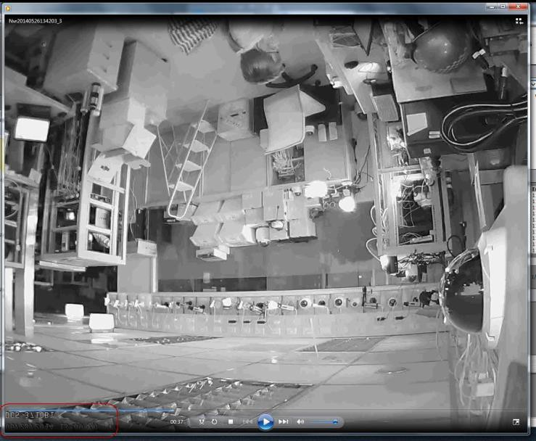DNR-312L FW Release Notes

Known Issue – Video export issue of DNR-312L NVR

Model: DNR-312L HW Ver.: A1
FW Ver.: V1.00.45

Issue Description:

Video clips will be flip when user export recorded video from browser and DNR-312L NVR.

Root cause:

This issue is only happened in browser and DNR-312L NVR when user export recorded video. Local UI

11

DNR-312L FW Release Notes

of DNR-312L NVR and Playback manager application will not to happen this problem.

The root cause is DNR-312L NVR needs to add OSD (On Screen Display) characters on the video clip, but some of video clips will be flip if user’s PC memory has problem during swap video clip from memory to hard disk.
To avoid this problem happen, suggest users to use Local UI of DNR-312L NVR or Playback manager application to do video exxport when user’s PC cause this issue.

Improvement:

Alert users this issue to be a known issue with FW V1.00.45. Vendor will improvement memory swap mechanism in the next FW version to avoid this issue happen again.

12

