D-Link DU-562M
External MODEM

Conexant HCF V.90

User’s Guide

FCC Requirements
This equipment complies with Part 68 of the FCC Rules. On the bottom of this equipment is a label that contains, among other information, the FCC Registration Number and Ringer Equivalence Number (REN) for this equipment. IF REQUESTED. THIS INFORMATION MUST BE GIVEN TO THE TELEPHONE COMPANY.

The REN is useful to determine the quantity of devices you may connect to your telephone line and still have these entire devices ring when your telephone number is called in most. But not all areas the sum of the REN’s of all devices connected to one line should not exceed five (5.0). To be certain of the number of devices you may connect to your line. As determined by the REN. You should contact your local telephone company to determine the maximum REN of the area you are calling from. If your telephone equipment causes harm to the telephone network. The Telephone Company may discontinue your service temporally. If possible, they will notify you in advance. But if the advanced notice is failed, you will be notified as soon as possible. You will be informed of your right to file a complaint with the FCC.

Your telephone company may change in its facilities, equipment, operations or procedures that could affect the proper functions of your equipment. If this occurs, you will be notified in advance to give you an opportunity to maintain uninterrupted telephone service.

If you experience trouble with this telephone equipment, please contact the following address and phone number for information on obtaining service or repairs. The Telephone Company may ask you to disconnect this equipment from the network until the problem is solved or until that the equipment is not detected malfunctioning. This equipment may not be used on coin service provided by the Telephone Company. Connection to party lines is subject to state Tariffs.
Federal Communications Commission
Radio Frequency Interference Statement.
Note: This equipment has been tested and found to comply with the limitation for a lass B digital device pursuant to Part 15 of the FCC Rules. These restrictions are designed to provide reasonable protection against harmful interference when the equipment is operated in a residential installation. This equipment generates, uses, and can radiate radio frequency energy and if not installed and used in accordance with the instruction manual may cause harmful interference to radio communications. However, there is no guarantee that interference will not occur in a particular installation. If the equipment does cause harmful interference to radio or television reception, which can be determine by tuning the equipment off and on, the user is suggested to try to correct the interference by one or more of the following measures:
-Reorient or relocate the receiving antenna.
-Increase the distance between the equipment and receiver.
-Connect the equipment into an outlet on a circuit different from that to which the receiver is connected. Consult the dealer or an experienced radio TV technician for help.
Notices:
- The changes or modifications not expressly approved by the party responsible for compliance could void the user’s authority to operate the equipment.
- Shielded interface cables and AC power cord if any must be used in order to comply with the emission limits.

Notices to Australian users:
The modem card must only be used in a data terminal equipment (DTE) e.g. computer, that has a screw down cover (lid). As unsafe voltages (TNV) exist on the modem card, disconnect the modem card from the telephone line while the cover (lid) of the DTE (computer) is removed.

Installation of the modem card in a DTE (computer) which does not require a tool to open the cover (lid) will render the permit void.

Disconnect the telephone line before opening the cover (lid) of the DTE (computer). Do not connect the customer equipment to the telephone line while the cover (lid) of the DTE (computer) is open.

WARNING
ONLY CONNECT EQUIPMENT WITH A TELECOMMUNICATIONS
COMPLIANCE LABEL

WARNING
FOR SAFETY REASONS, ONLY CONNECT EQUIPMENT WITH A TELECOMMUNICATIOS COMPLIANCE LABEL. THIS INCLUDES CUSTOMER EQUIPMENT PREVIOUSLY LABELLED
PERMITTED OR CERTIFIED.

Modems connected to the Australian telecommunications network must be marked in accordance with the Labeling Notice. This modem has been specifically configured to ensure compliance with the ACA Standards. Do not adjust your modem or software outside the values indicated as below. To do so would result in your modem being operated in a non-compliant manner.
Modem Commands:
Command Default Permissible Range
ATA - Do not use
ATB B0 Do not set to B1
AT&G &G0 &G2
AT&P &P0 &P1
ATSn see table below
S register Default Permissible Range
s6 2 2 to 6

Call Attempts/Retries:
Applications software shall be configured so that no more than 3 attempts are made to
establish a connection to a given number (Note: if the modem can detect service tones, up to 10 attempts can be made). If the call sequence is unsuccessful, there shall be a delay of at least 30 minutes before attempting to call the number again.

Failure to set the modem and any application software used with the modem, to the values
shown as above will result in the modem being operated in a non-compliant manner.
Consequently, this would be in violation of the Labeling Notice for this equipment, and the Telecommunications ACT 1997 prescribes penalties for the connection of non-compliant equipment.

Table of Contents

Chapter 1 Introduction 5
1.1 Introduction 5
1.2 What’s in the package 5

Chapter 2 Specifications 6

Chapter 3 Hardware Installation 7

Chapter 4 Software Installation 8
4.1 Windows 98 8
4.2 Windows ME 10
4.3 Windows 2000 11
4.4 Windows XP 13

Chapter 5 Select Modem Country 15

5.1 Windows 98/ME/2K 15
5.2 Windows XP 16

Chapter 6 Diagnostics 17
6.1 Windows 98/ME 17
6.2 Windows 2000 19
6.3 Windows XP 22

Chapter 7 Uninstalling 25
7.1 Windows 98/ME 25
7.2 Windows 2K 27
7.3 Windows XP 29

Chapter 8 Troubleshooting 31

Chapter 1 Introduction
1.1 Introduction
Thank you for choosing the D-Link DU-562M External Modem. It is not only the
most cost-effective solution to connect your PC to the Internet, but also increase the
usage of the CPU and decrease the cost of ownership. It reduces the time and pain
during installation procedure. All you have to do are just plug & play and inserting the
CD-ROM Disk, even that you don’t need to turn off the power of your PC. Because it’s a
really USB device so it supports the fully HOT plug and play function. Furthermore, it
follows the K56Flex /V.90 Standard, you can access the Internet at Max. rate 56K bps (It
depends on the line condition and the ISP you connected to). If you have a PC system
with USB interface, we strongly recommend you to take this modem as your best choice.
1.2 Features
USB interface, HOT plug and play, easy to install
ITU 56K V.90 Standard
Windows 98SE /Windows ME/Windows 2K /Window XP compatible
No Extra Power Needs & Low power consumption
Host-Controlled Modem
User Friendly
1.3 What’s in the Package
Modem Unit
CD-ROM Disk (Comprises Application Software, Modem Drivers & User’s Manual)
Telephone cord
Quick Guide for Installing Modem Drivers

Chapter 2 Specifications
2.1 Specifications
Computer Interface USB V1.1
Line Interface RJ-11 for POTS line
Data Protocols V.90, K56flex, V.34, V.32bis, V.32, V.22bis, V.22, V.23, V.21, Bell
212A and 103
Data Speed 56k, 54k, 52k, 50k, 48k, 46k, 44k, 42k, 40k, 38k, 36k, 34k, 33.6k,
31.2k, 28.8k, 26.4k, 24k, 21.6k, 19.2k, 16.8k, 14.4k, 12k, 9600, 7200,
4800, 2400, 1200, 300
Data Compression V.42bis, MNP 5
Error Correction V.42 LAPM, MNP 2,3,4
Fax Protocols Group 3 Compatible, Class 1 fax: V.17, V.29, V.27ter, V.21 ch 2
Fax Speed 14.4k, 12k, 9600, 7200, 4800, 2400, 300
General Sandard AT commands, V.8 and Automode, Caller ID, Virtual DTE,
V.80 Virtual UART (115.2kbps), DTMF detection and generation,
ADPCM, Answering machine (voice), OnNow Power Management,
Wake-up on ring , Distinctive ring for data/fax/voice, World wide
country support
Power Consumption below 700mW
2.2 System Requirements
CPU : Pentium 200MHz MMX comptible or greater
RAM : 16Mbyte RAM or more
Interface : USB port
HDD : 2MB free space or above
Telecom Requirement : 1 POTS line
Operation system : Windows 98SE , Windows ME, Windows 2K, Windows XP
Chapter 3 Hardware Installation
1. Plug the connector of the USB Modem into the USB port of your PC.
2. Plug one end of telephone cord into the modem’s “LINE” jack, which is shown on the
modem’s bracket labeled “LINE”.
3. Insert the other end of the cord into the telephone wall socket.
4. Enable the USB port option in the BIOS setup of your computer.

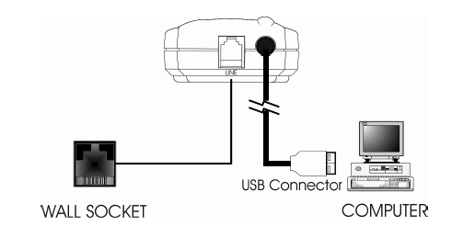

Chapter 4 Software Installation
The following sections explain how to install the modem drivers under Windows 98se/ME/2000/XP. Refer to the section, which best suites, your operating system.

4.1 Windows 98se
- The computer wizard will find new hardware device, Please click Cancel to
continue.

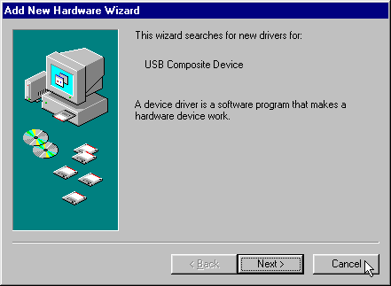

- Please click Start \ Run on the desktop, then type the path:
I:\Driver\Win98SE\Hxfsetup.exe ( I is the letter of CD-ROM drive ) and
click OK to continue.

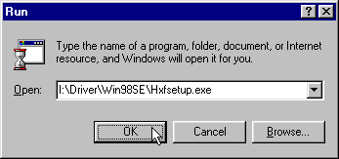
- Click Yes.

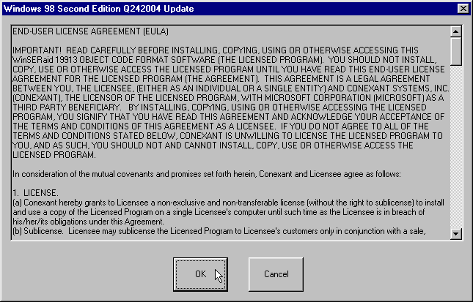

- Click Yes, restart computer now.

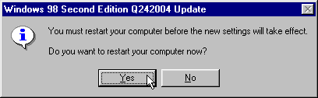
4.2 Windows ME
- The computer wizard will find new hardware device, Please click Cancel to
continue.

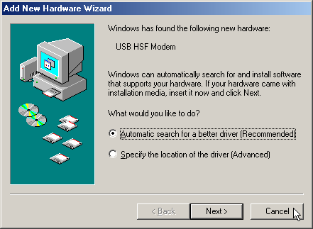

- Please click Start \ Run on the desktop, then type the path:
I:\Driver\WinME\HXFSetup.exe ( I is the letter of CD-ROM drive ) and
click OK to continue.

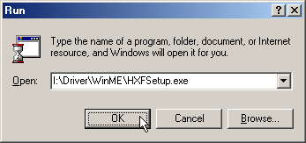

4.3 Windows 2000

- The computer wizard will find new hardware device, Please click Cancel to
continue.

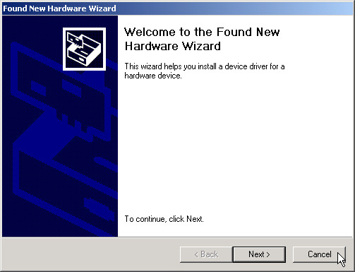

- Please click Start \ Run on the desktop, then type the path:
G:\Driver\Win2K\HXFSetup.exe ( G is the letter of CD-ROM drive ) and
click OK to continue.

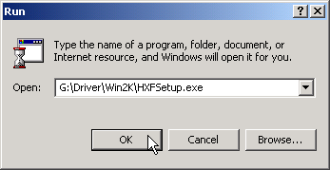
- Click Yes，to continue this installation procedure

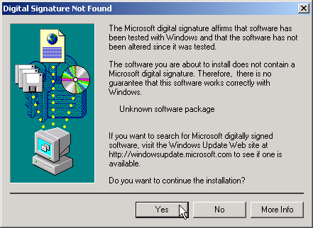

- Click Yes

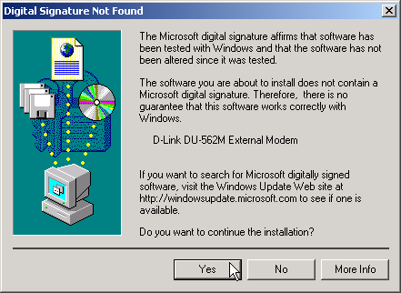

  - Windows XP

- Please insert the driver CD supplied when you see the message of PCI Simple Communications Controller, Select the Install from a list or specific location [Advanced] then click Next to search for the driver.

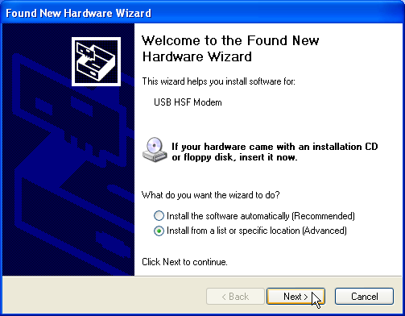

- Select Include this location in the search: and type a path: G:\Driver\WinXP (G is the letter of the CD-ROM drive), then click Next to continue.

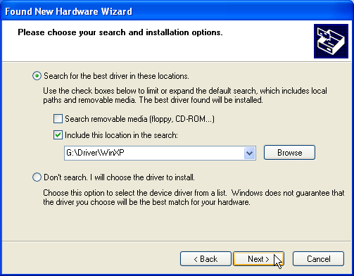
- Click Continue Anyway to continue.

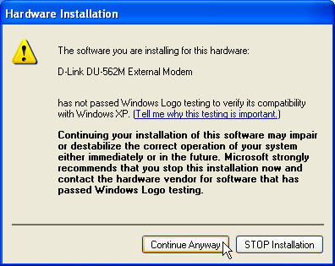

- Click Finish to end this procedure.

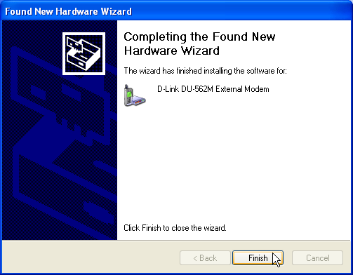

Chapter 5 Select Modem Country
The following sections explain how to install the modem drivers under Windows 98/ME/NT4.0/2000/XP. Refer to the section, which best suites, your operating system.

5.1 Windows 98/ME/2K
- Move your courser as following sequence Start\Settings\Control Panel and click Control Panel. Then double-click on the HSF Modem Region Select icon.

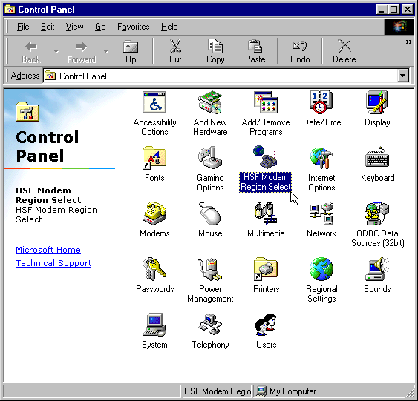
- Select your country from a list, then click OK

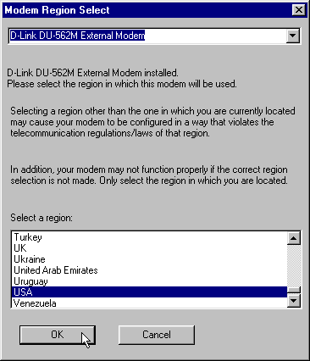

5.2 Windows XP

- Move your courser as following sequence Start\Settings\Control Panel and click ControlPanel. Then double-click on the HSF Modem Region Select icon.

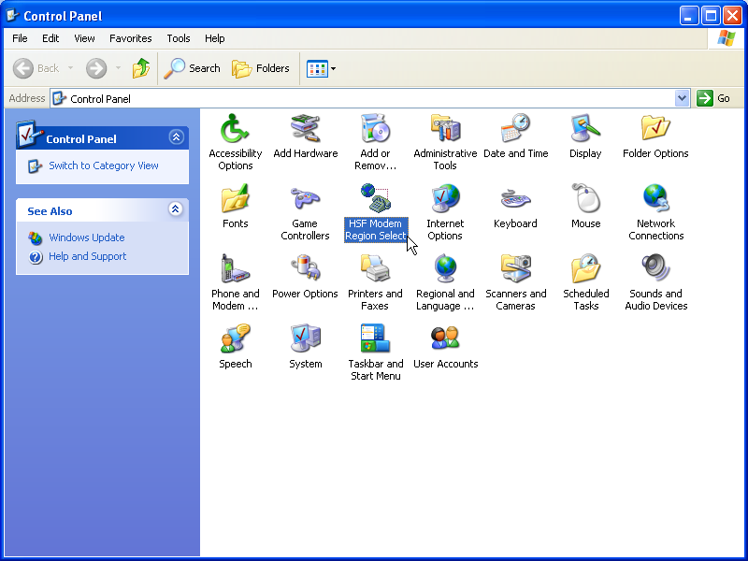

2. Select your country from a list, then click OK

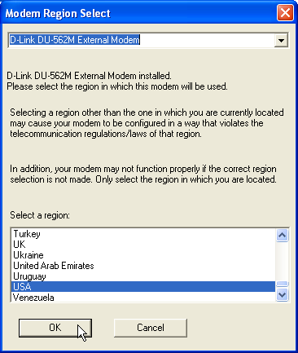

Chapter 6 Diagnostics
6.1 Windows 98se/ME
- Move your cursor as following sequence Start / Settings / Control Panel and double-click on the Modems icon.

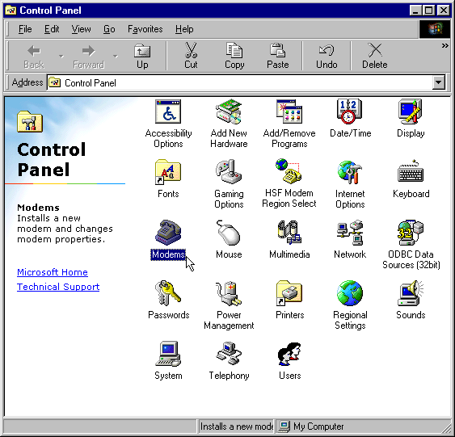

- TO test the Modem by clicking on the Diagnostics tab，Select the COM3 port
that Modem is setting，and click More Info…..

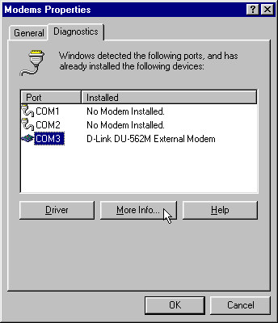

- If your modem is responding to AT commands and functioning correctly, it means that your modem is working properly. Click OK to end this procedure.

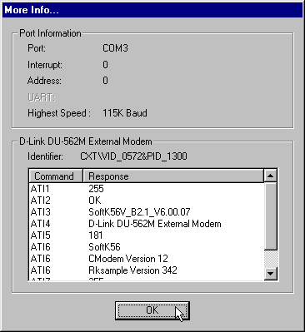

4. Click OK to end this procedure.

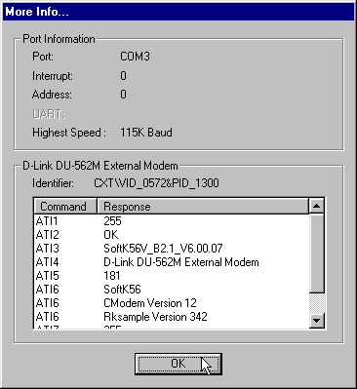
6.2 Windows 2000
- Move your cursor as following sequence Start\Settings\Control Panel. Then double-click on the Phone and Modem Options icon.

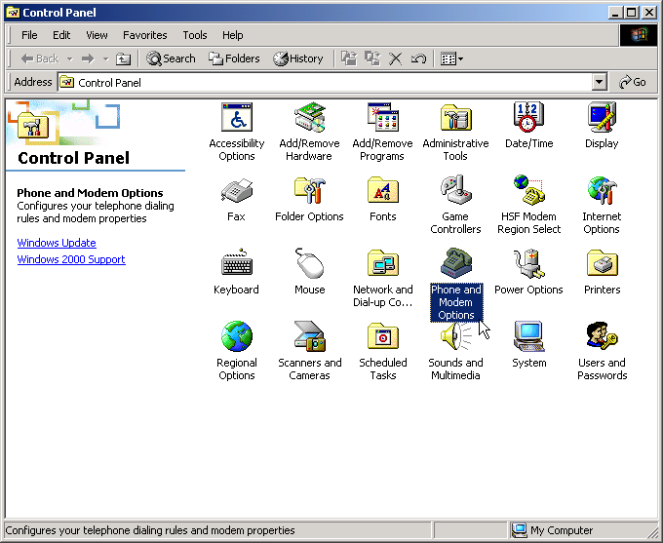

- Click Modems tab, then select D-Link DU-562M External Modem and click Properties.

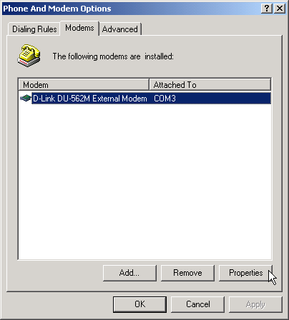

- Click Diagnostics tab, then click Query Modem.

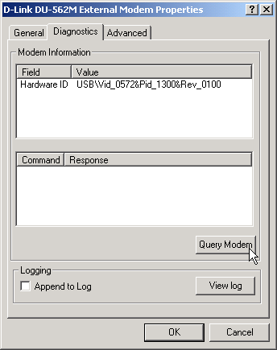

- If your modem is responding to AT commands and functioning correctly, it means that your modem is working properly. Click OK.

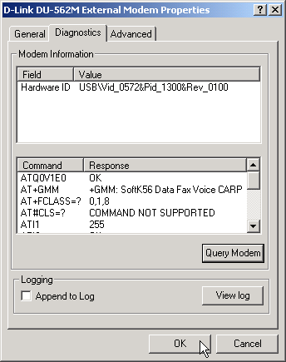

5. Click OK to end this procedure.

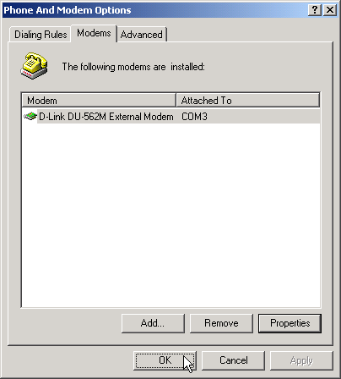
6.3 Windows XP
- Move your cursor as following sequence Start\Settings\Control Panel. Then double-click on the Phone and Modem Options icon.

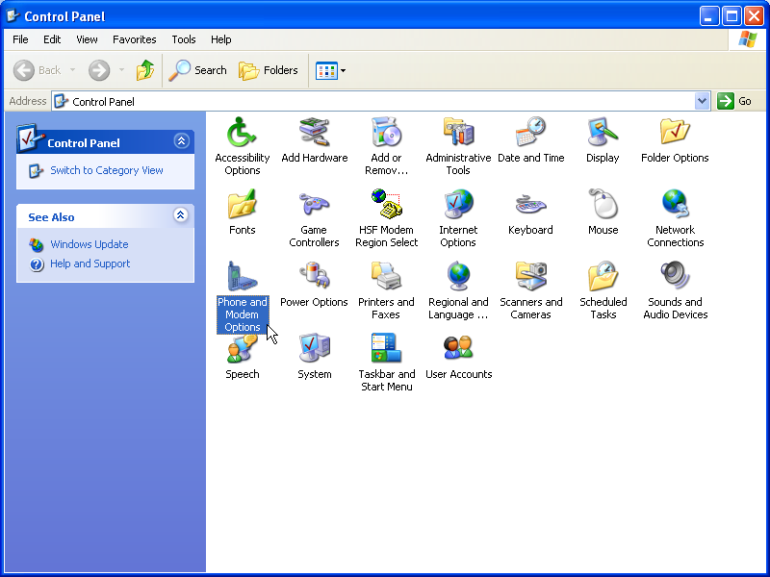

- Click Modems tab, then select D-Link DU 562M External Modem and click Properties.

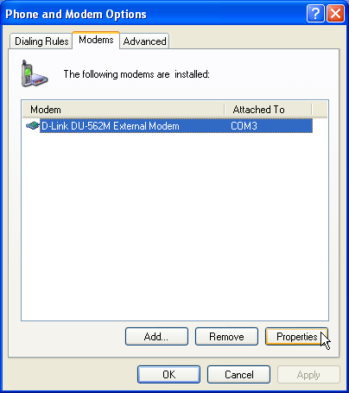
- Click Diagnostics tab, then click Query Modem.

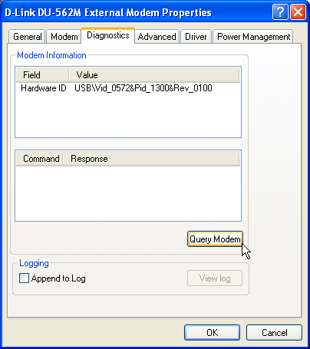

- If your modem is responding to AT commands and functioning correctly, it means that your modem is working properly. Click OK.
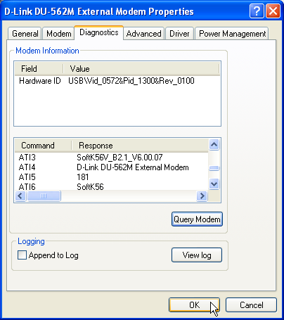

- Click OK to end this procedure.

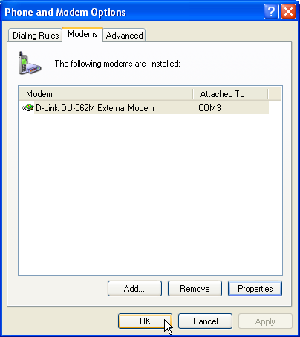

Chapter 7 Uninstalling
7.1 Windows 98se/ME
- Move your cursor as following sequence Start / Settings / Control Panel and double-click on the Modems icon.

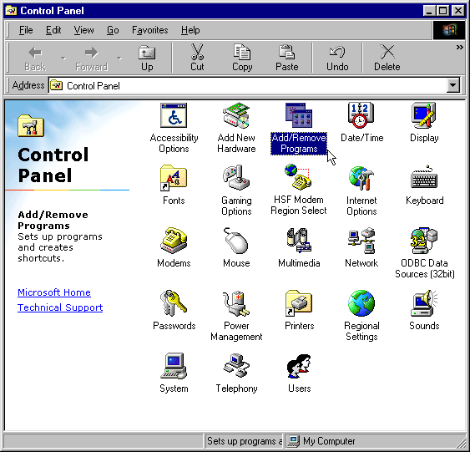

- Select D-Link DU-562M External Modem , then click Remove.

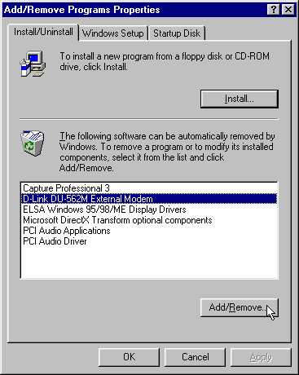

- Click Yes to restart your computer and end this procedure

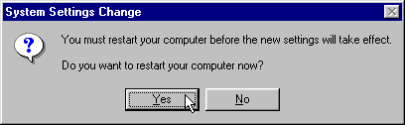

7.2 Windows 2000
- Move your cursor as following sequence Start \ Settings \ Control Panel. Then double-click on the Add/Remove Programs icon.

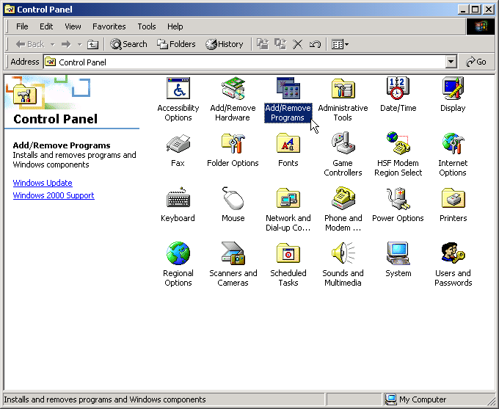

- Select D-Link DU-562M External Modem from the list，and then click Remove

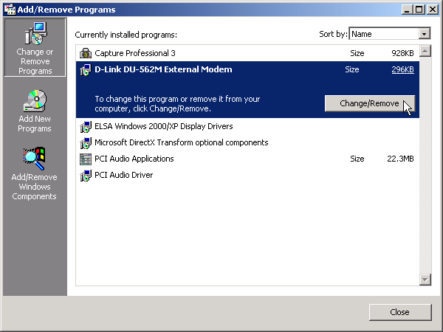
- Click Close to end this procedure

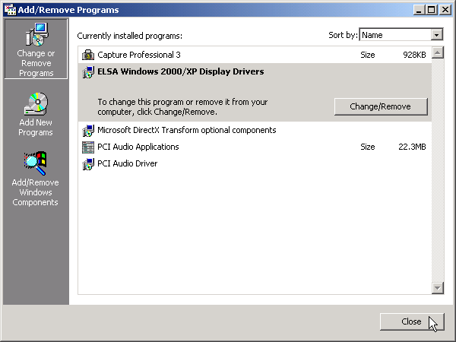

7.3 Windows XP
- Move your cursor as following sequence Start \ Settings \ Control Panel. Click on the Add Remove Programs icon.

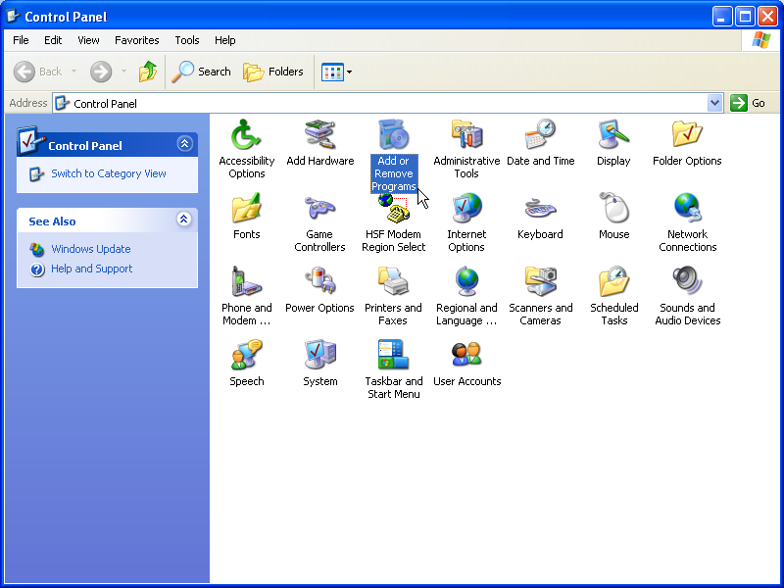

- Select D-Link DU-562M External Modem, then click Remove.

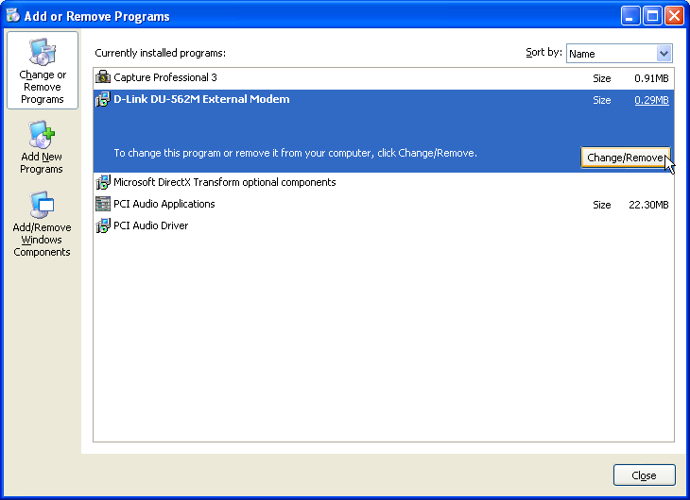
- Then click Close to end this procedure

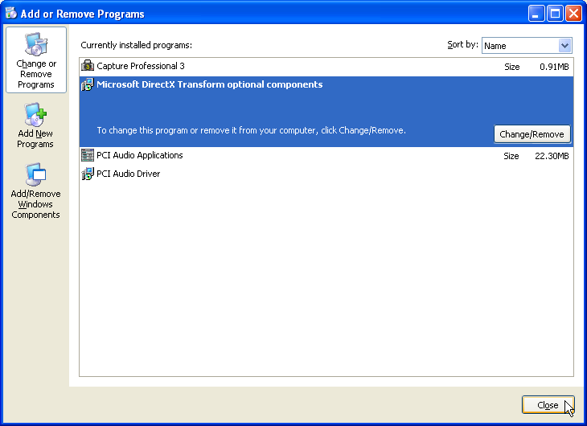

0Chapter 8 Troubleshooting

Modem will not dial-out
- Check your phone cable connected properly into LINE jack.
- If you use the Tone-dialing on a line, but required the Pulse-dialing method, please change the command T to P in your dial command line.

Modem will not answer an incoming call
- Check your phone cable connected properly into LINE jack.
- By connect a Telephone to the PHONE jack. The attached telephone will ring if you try calling from another telephone line.
- Configured the modem to Auto-answer modem.

No connection after modem dial out
- Remote modem may be not setting to answer mode, if you aren’t hearing a high-pitch tone when remote modem answering.
- Perhaps poor-quality or noise telephone lines try another call.

Data error when modem connection
- Make sure your software data format is match to remote side (for example: 8,N, 1).
- Make sure the modem flow control method is matched to communication software.
- Try another call may be poor quality or noise telephone lines.

Fax and voice problems
- Be sure the Data Communication is installed and worked properly, otherwise check the mentioned procedure carefully and consult the Fax/Voice manual step by step.

