How to allow user only accessing the specific WEB domains.

Object:
The network administrator want the users only can access the web site with the specific domain name as government web site, and block the all of rest.

Configuration:
Go to the Object\ALG\http-outbound ALG setting page and add a rule to blocking all domain as the following screenshot.
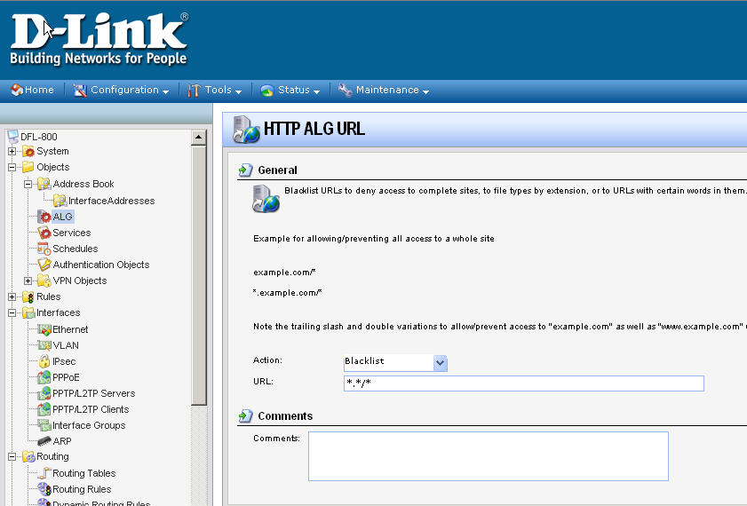
In the same setting page, add another rule for allow government web site. In this case I use the gov.tw domain to be an example.
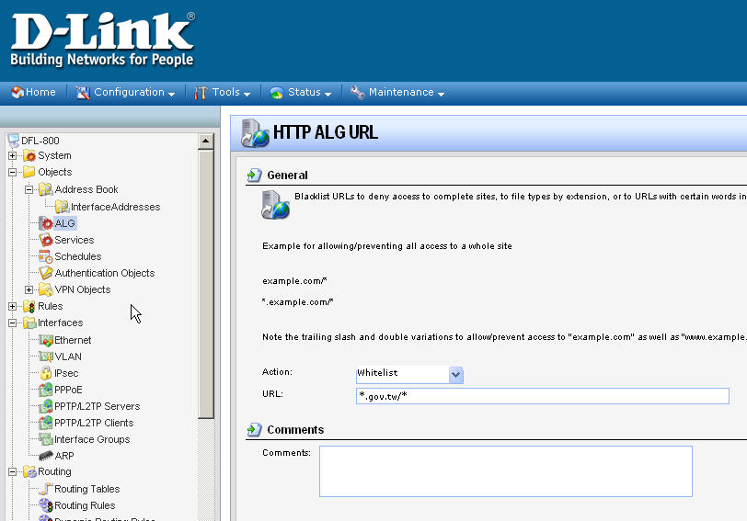
Delete the default rules allowing user to access FTP and all TCP/UDP service in Internet.
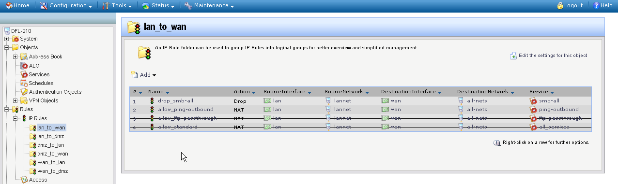
Add a rule to allow user can access DNS server, if your DNS server is not in LAN
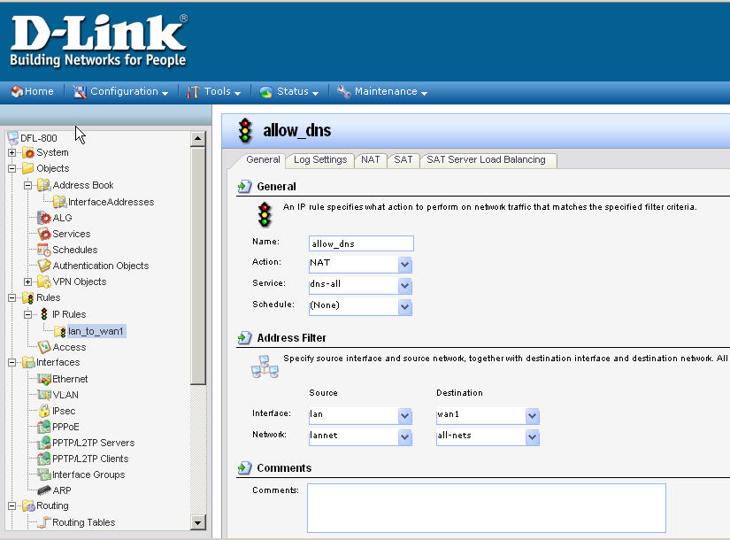
Add a rule for user to access HTTP service as the following. 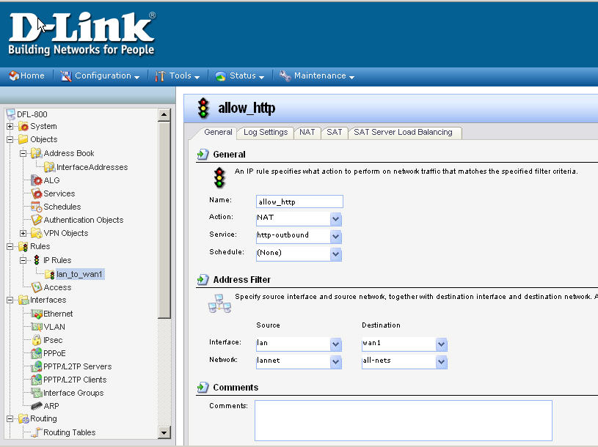
Please make sure the HTTP service object in previous rule must contain the ALG object setup in step 1.
