How to Configure ZoneDefense for D-Link switch model DES-3226S
This example will show how to configure the firewall to use ZoneDefense.
Details:
The local network contains a D-Link DES-3226S switch. This example shows how to define a Microsoft-DS Threshold (TCP port 445) of 10 connections/second (eg, the work SASSER.A will send out a large amount of TCP SYN on port 445). If the number of connections exceeds this limitation, the firewall will block the specific hosts port on the switch (host 192.168.2.10 in this scenario). The switch port connected to the firewall should be configured to use 192.168.1.250 and the community string MyCompany.

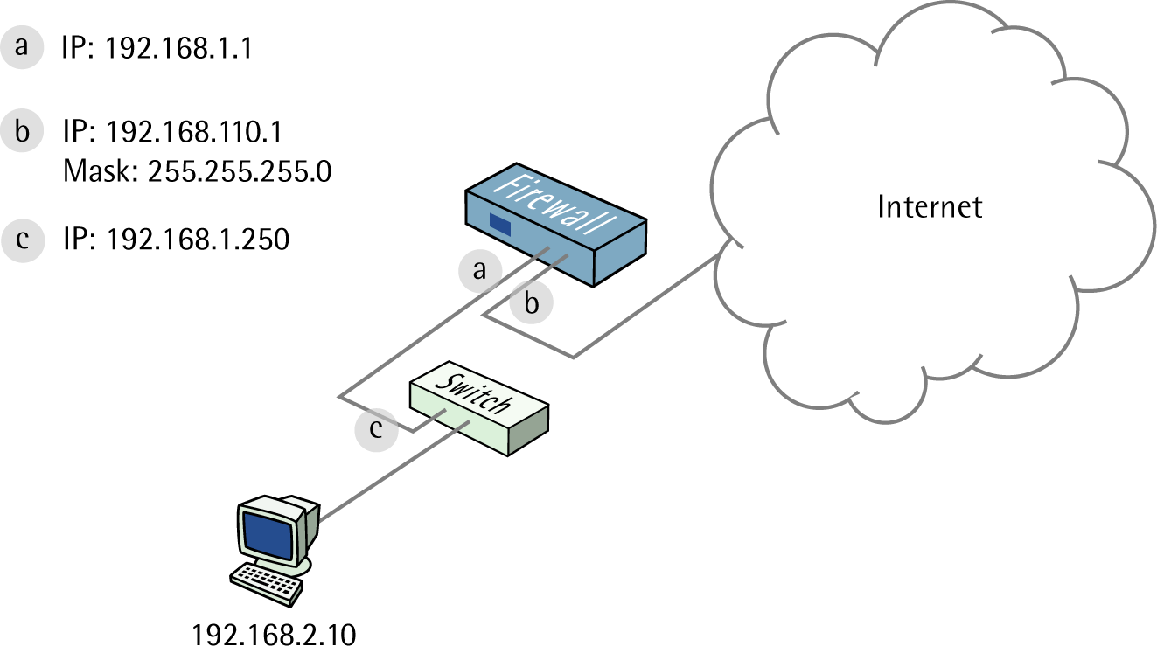

1. Addresses
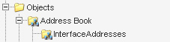
Go to Objects -> Address book -> InterfaceAddresses.
Edit the following items:
Change lan_ip to 192.168.1.1
Change lannet to 192.168.1.0/24

Change wan1_ip to 192.168.110.1
Change wan1net to 192.168.110.0/24

Go to Objects -> Address book.

Add a new Address Folder called LocalHosts.

In the new folder, add a new IP address:
Name: DES-3226S
IP Address: 192.168.1.250

Click Ok

2. Switch set up
Go to ZoneDefense -> Switches.

Add a new ZoneDefense Switch:

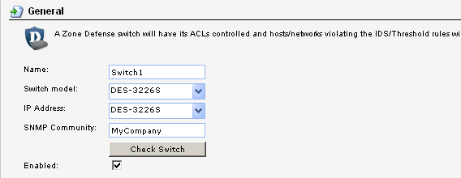
General:

Name: Switch1
Switch Model: DES-3226S
IP Address: DES-3226S (this is the IP of the port on the switch that is connected to the firewall)
SNMP Community: MyCompany
Check the Enabled box

Clicking Check Switch can check the settings and connectivity.

Click Ok.

3. Exclude list
To prevent the firewall from accidentally being locked out from accessing the switch, add the firewall’s interface for managing the switch into the exclude list.

Go to ZoneDefense -> Exclude.

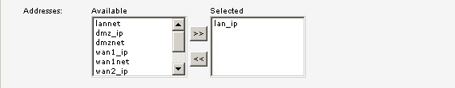
General:

Select lan_ip and add it to the selected list.

Click Ok.

4. Threshold rules
Go to Traffic Management -> Threshold Rules.

Add a new Threshold Rule.

In the General tab:

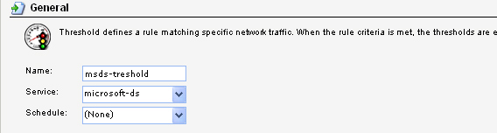
General:

Name: msds-threshold
Service: microsoft-ds
Schedule: (None)

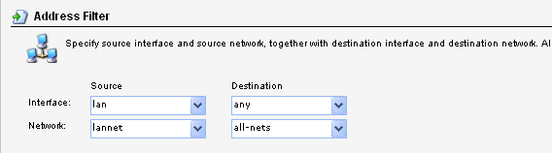
Address Filter:

Source interface: lan
Source network: lannet
Destination interface: any
Destination network: all-nets

In this new Threshold Rule, add a new Threshold Action.

In the General tab:

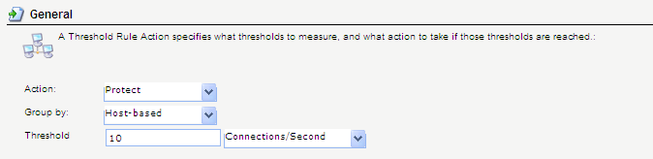
General:

Action: Protect
Group by: Host
Threshold: 10 Connections/Second

ZoneDefense:

Check the Use ZoneDefense box

Click Ok.

Save and activate the configuration.

