New Firmware Upgrade Procedure

Users have to upgrade three different firmware files (fwu.hex, wssldr.hex, fwn.hex) in order to accomplish new firmware (v4.10.02) upgraded. Users can upgrade firmware through SmartConsole Utility or Web GUI as following steps:

File Requirement:
 | DGS-1216T v.D1 | DGS-1224T v.D1
fwu.hex | 1216TFWU.hex | 1224TFWU.hex
wssldr.hex | 1216Tldr.hex | 1224Tldr.hex
fwn.hex | 1216TFWN.hex | 1224TFWN.hex

1. Upgrade firmware through SmartConsole Utility (Please refer to below step. i-xi)

Execute smart console utility
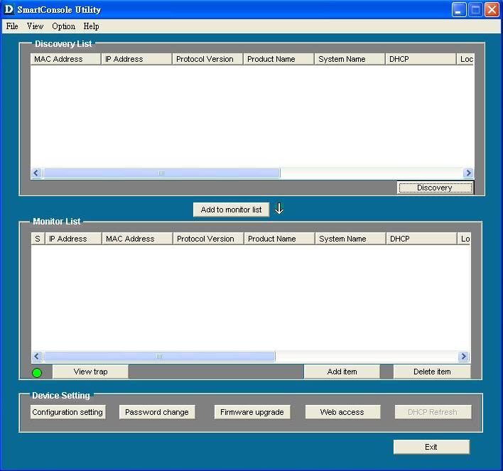

Click Discovery button to search target switch
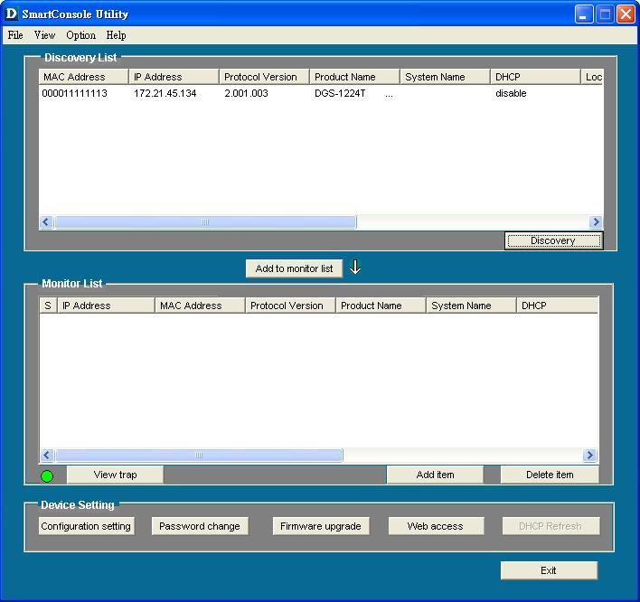

Double click target switch to add to monitor list
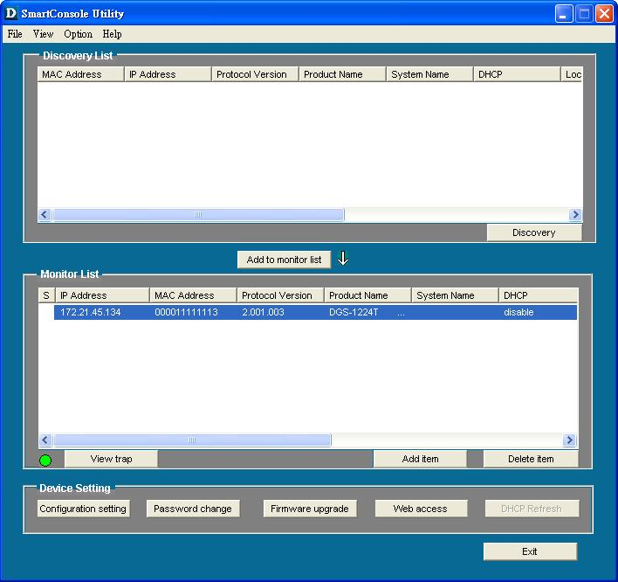

Click firmware upgrade button
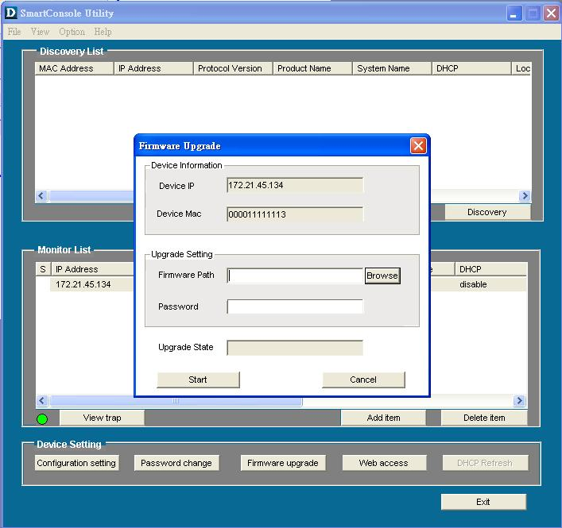

Click Browse button to search fwu.hex firmware file from user’s local PC
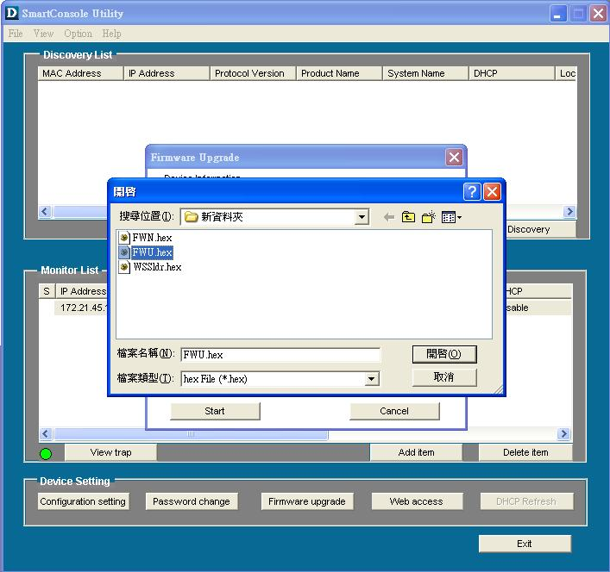

Enter password and click start button to start firmware upgrade
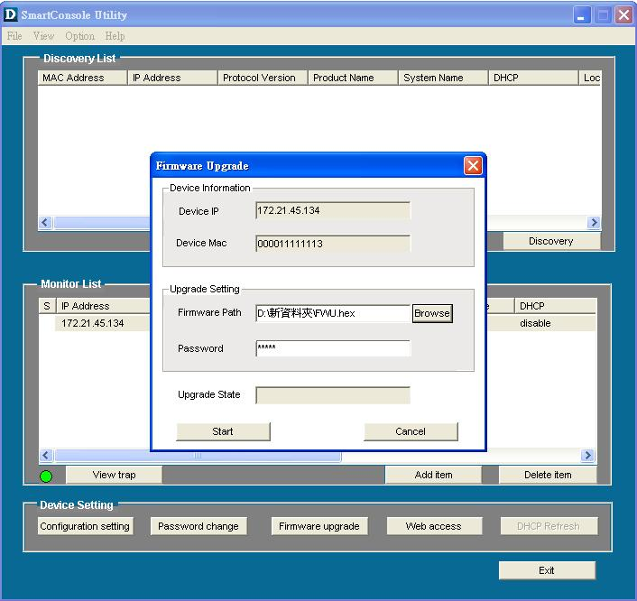

Wait for firmware upgrade complete
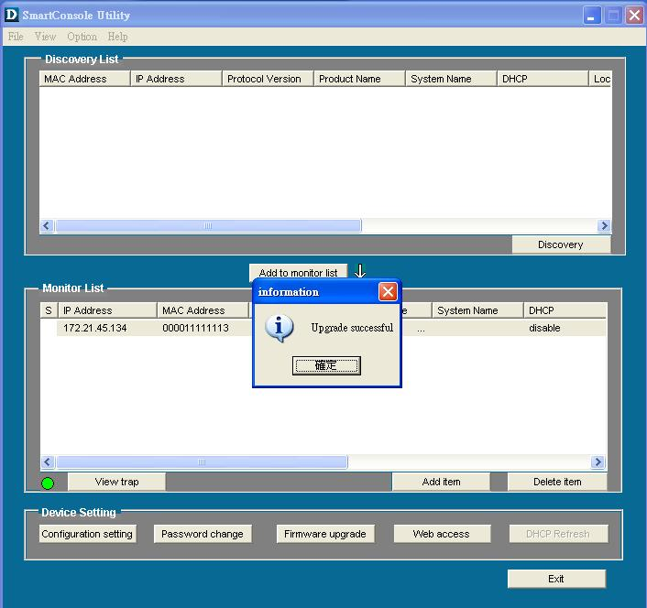

Repeat step.i ~ step.vii, but choose WSSldr.hex to upgrade in step.v
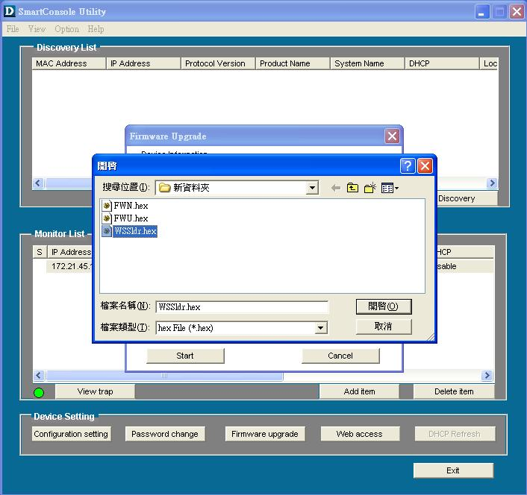

Repeat step.i ~ step.vii , but choose fwn.hex to upgrade in step.v
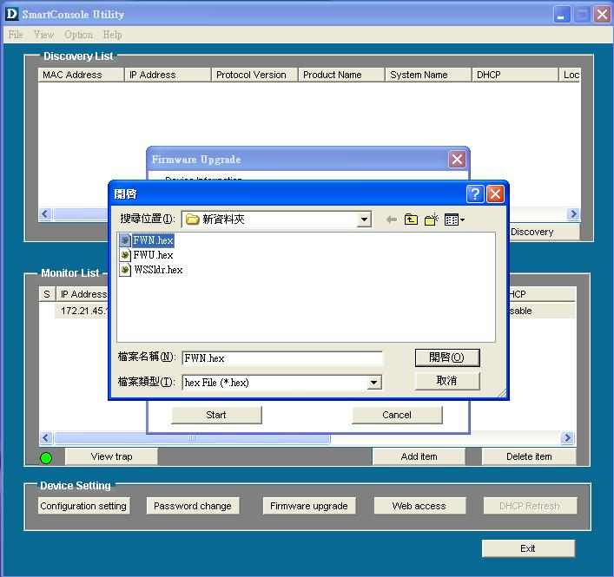

2. Upgrade firmware through Web GUI (Please refer to below step. i-vi)

Open web GUI , clicking tool and choosing Firmware Backup & Upload
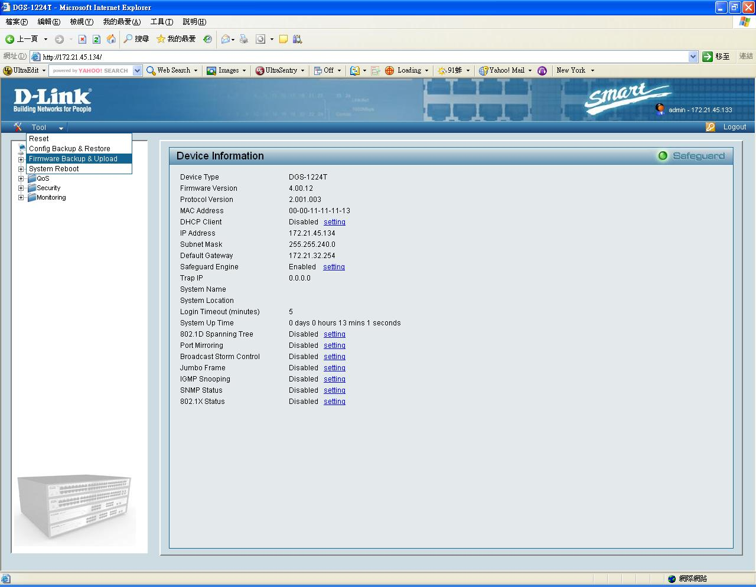

Click browse button and choose fwu.hex firmware file from local user’s PC
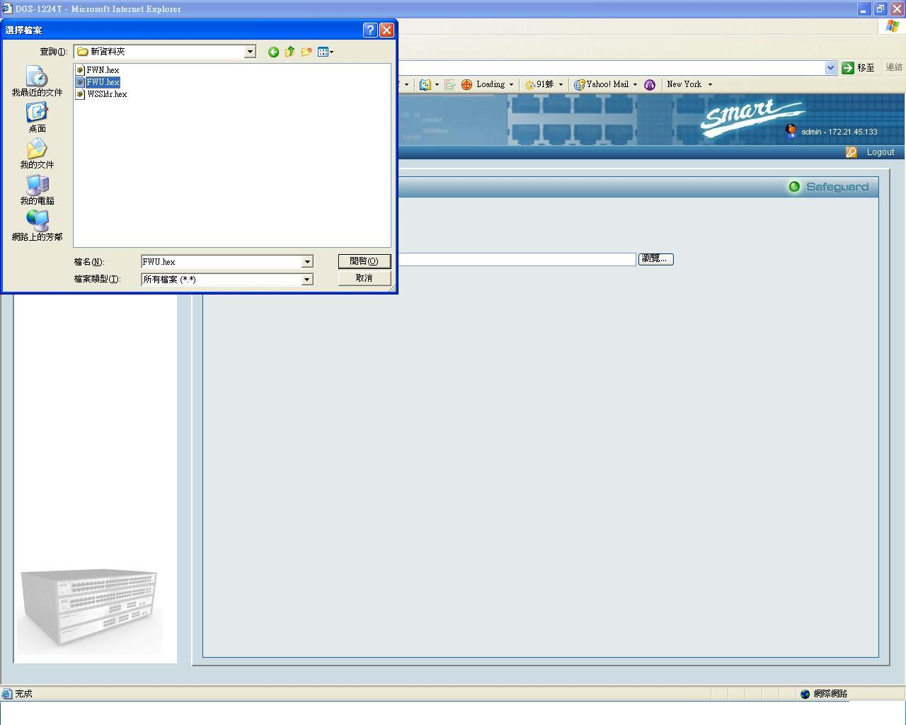

Click Upload button to start upgrade firmware
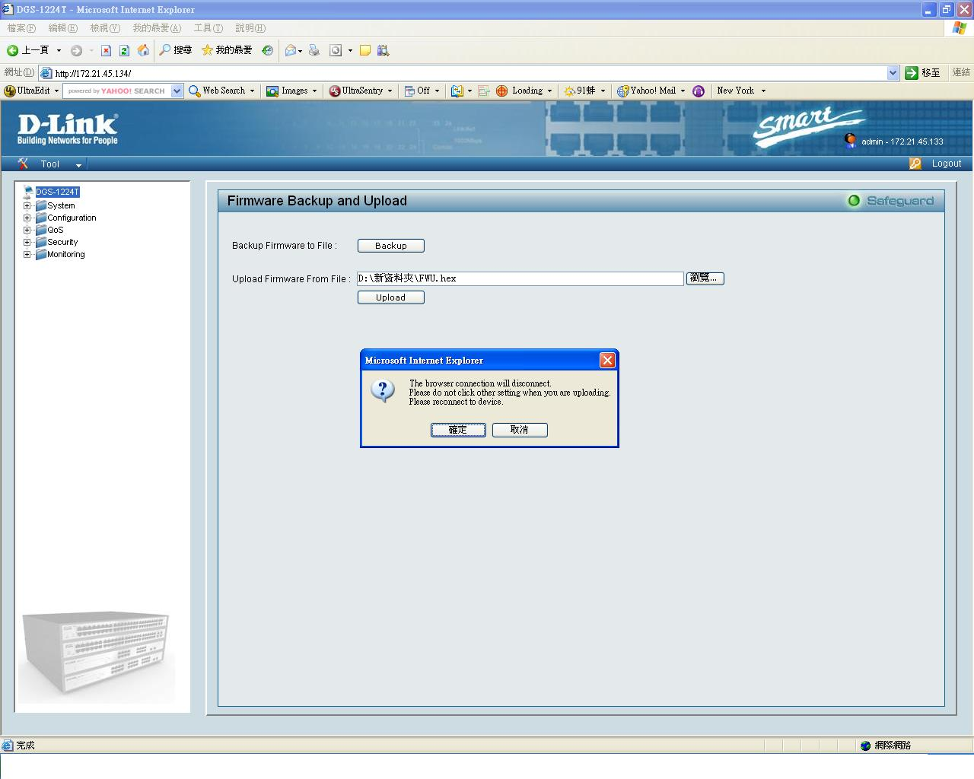

iv. Wait for firmware upgrade complete then restart Web GUI

v. Repeat step.i ~ step.iv , but choose WSSldr.hex in step.ii

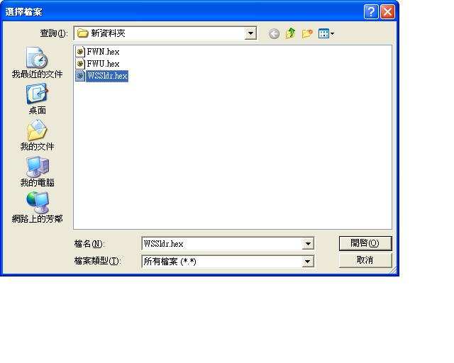

Repeat step.i ~ step.iv , but choose fwn.hex in step.ii
