

Firmware Version: | v2.00r131
Published Date: | 2019/09/18

Content:
Upgrading Instructions: 2
Upgrading by using Web-UI 2
New Features: 2
Changes of MIB & D-View Module: 2
Problems Fixed: 2
Known Issues: 3
Related Documentation: 3

Revision History and System Requirement:
Firmware Version | Date | Model | Hardware Version
v1.20rc075 | 2016/09/14 | DAP-2695 | Ax

Upgrading Instructions:
D-Link AP supports firmware upgrading via Web-UI. You may download the firmware from D-Link web site http://tsd.dlink.com.tw.

Upgrading by using Web-UI
- Connect a work station to the LAN port of Access Point.
- Open the web browser of work station and entering the IP address of the AP. The system
default IP address is 192.168.0.50.
- Enter administrator’s username and password, user name is “admin” and leave
the password field blank by default.
To update the AP's firmware, click Maintenance > Firmware and SSL Certification Upload
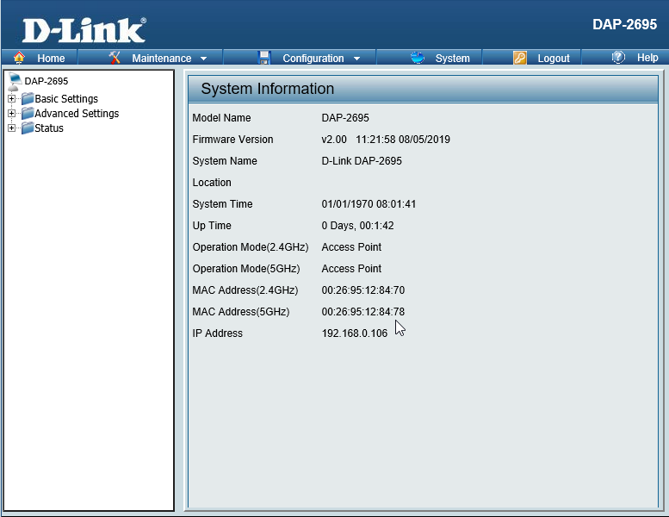

New Features:
- Use QCA's WDS
- Remove AP Array
- Support Nuclias Connect
- Support DDPv5/APP
- Use QCA’s Band steering
- In default settings, the network IP address setting is Dynamic IP
- Support MDNS
- Modify Time zone settings
- Update country selection table
- Move IP filter settings page from Captive Portal to Filter folder, behind WLAN Partition (AP GUI). IP filter function is independent feature and can work with all non-captive portal authentication.
- Default admin user name/password is admin/admin
- Add setup Wizard when first login

Changes of MIB & D-View Module:
None

Problems Fixed:
Firmware Version | Problems Fixed
V2.00 | - D-track -> Fix wrong RADIUS accounting attribute

Known Issues:
Firmware Version | Known Issues
V2.00 | None

Related Documentation:
- DAP-2695 User Manual v2.00

