

Firmware Version: | 1.10rc009
Published Date: | 2012/2/2

Content:
Upgrading Instructions: 2
Upgrading by using Web-UI 2
New Features: 2
Changes of MIB & D-View Module: 2
Problems Fixed: 2
Known Issues: 3
Related Documentation: 3

Revision History and System Requirement:
Firmware Version | Date | Model | Hardware Version
1.03rc004 | 2010/12/14 | DAP-3520 | A1
1.02rc003 | 2010/04/01 | DAP-3520 | A1
1.10rc009 | 2012/02/02 | DAP-3520 | A1

Upgrading Instructions:
D-Link AP supports firmware upgrading via Web-UI. You may download the firmware from D-Link web site http://tsd.dlink.com.tw.

Upgrading by using Web-UI
- Connect a work station to the LAN port of Access Point.
- Open the web browser of work station and entering the IP address of the AP. The system
default IP address is 192.168.0.50.
- Enter administrator’s username and password, user name is “admin” and leave
the password field blank by default.
To update the AP's firmware, click Maintenance > Firmware and SSL Certification Upload
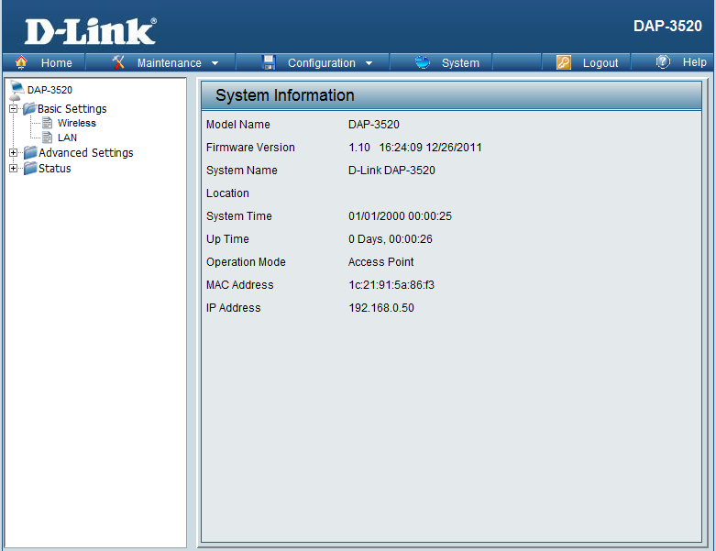

New Features:
Firmware Version | New Features
V1.10 | - Support AP Array Setup Utility

Changes of MIB & D-View Module:
None

Problems Fixed:
Firmware Version | Problems Fixed
V1.10 | - Fix the error for ACL file upload in D-View and APM2  - Fix the error info in the console log when running WDS endurance  - Fix the when select year then day cannot be select in Time and Date  - Correct the EG country code range  - Fix when enable wireless schedule and vlan function the AP cannot be manage

Known Issues:
Firmware Version | Known Issues
V1.10 | None

Related Documentation:
- DAP-3520 User Manual v1.10

