

Firmware Version: | 2.01
Published Date: | 2011/9/28

Content:
Upgrading Instructions: 2
Upgrading by using Web-UI 2
New Features: 2
Changes of MIB & D-View Module: 2
Problems Fixed: 2
Known Issues: 3
Related Documentation: 3

Revision History and System Requirement:
Firmware Version | Date | Model | Hardware Version
V2.00 | 2011/3/28 | DAP-3860 | B1
V2.01 | 2011/9/28 | DAP-3860 | B1

Upgrading Instructions:
D-Link AP supports firmware upgrading via Web-UI. You may download the firmware from D-Link web site http://tsd.dlink.com.tw.

Upgrading by using Web-UI
- Connect a work station to the LAN port of Access Point.
- Open the web browser of work station and entering the IP address of the AP. The system
default IP address is 192.168.0.50.
- Enter administrator’s username and password, user name is “admin” and leave
the password field blank by default.
To update the AP's firmware, click Administrator Settings > Firmware Upload
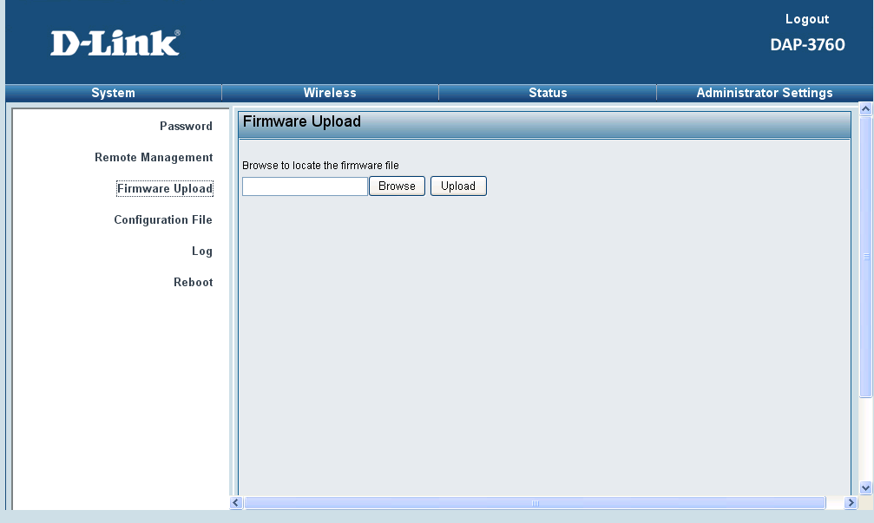

New Features:
Fireware Version | New Features
V2.01 | Add the country code US and RU on UI

Changes of MIB & D-View Module:
None

Problems Fixed:
Firmware Version | Problems Fixed
V2.01 | Safari browser compatibility failure

Known Issues:
Firmware Version | Known Issues
V2.01 | DWA-160 H/W A1&A2 can’t connect to DAP-3860 if DAP-3860 uses hide SSID and DWA-160 use D-Link utility (It works fine if DWA-160 uses windows zero configuration.

Related Documentation:
- DAP-3860 User Manual v2.00

