

|  |  |
| --- | --- |
| **Firmware Version:** | 1.10r027 |
|  |  |
| **Published Date:** | 2022/02/16 |
|  |  |

**Content:**

Upgrading Instructions: 2

Upgrading by using Web-UI 2

New Features: 2

Changes of MIB & D-View Module: 2

Problems Fixed: 3

Known Issues: 3

Related Documentation: 3

Revision History and System Requirement:

|  |  |  |  |
| --- | --- | --- | --- |
| **Firmware Version** | **Date** | **Model** | **Hardware Version** |
| v1.00r015  v1.01r018 | 2021/02/03  2021/05/18 | DAP-X2850 | A1 |

# Upgrading Instructions:

D-Link AP supports firmware upgrading via Web-UI. You may download the firmware from D-Link web site <http://tsd.dlink.com.tw>.

Please also

1. Make sure your DAP-X2850 has to manually assign a valid static IPv4 address or get a valid IPv4 address from DHCP server before upgrade FW.
2. Do not power off your DAP-X2850 when FW upgrading.

## Upgrading by using Web-UI

1. Connect a work station to the LAN port of Access Point.
2. Open the web browser of work station and entering the IP address of the AP. The system default IP address setting is dynamic ip, and you can enter <http://dapx2850.local> to login, if it cannot get ip address from DHCP server, it’s ip address will back to 192.168.0.50.
3. Enter administrator’s username and password, user name and password are “admin” by default.

To update the AP's firmware, click **Maintenance > Firmware and SSL Certification Upload**

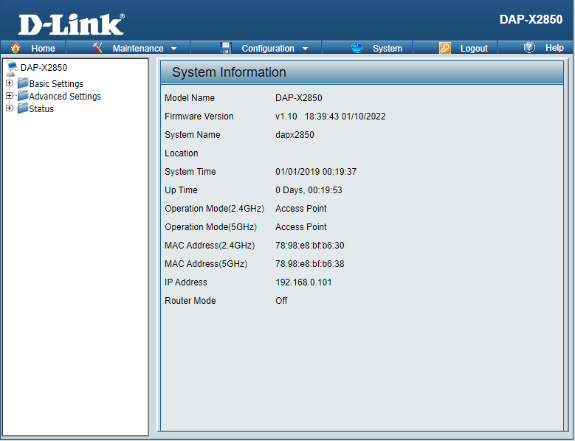

# New Features:

1. Upgrade SDK to SPF11.4
2. Upgrade Openssl
3. Support DNC 1.2.0.6 new feature
4. Add channel 165 for KR country code
5. Add Slovenia and Kosovo in country selection table

# Changes of MIB & D-View Module:

None

# Problems Fixed:

|  |  |
| --- | --- |
| **Firmware Version** | **Problems Fixed** |
| V1.10 | 1. Fix DBG21020140 - Captive Portal (MAC address authentication) UI shows incorrectly. 2. Fix HQ20210129000004 - Misspelling on Client Information 3. Fix DI20211129000009 - IPv6 setting issue 4. Fix DI20211130000007 - VHT Operation - Channel Width: 20 MHz or 40 MHz (0x00) 5. Fix DI20211202000003 – Doesn't restart udhcpc after enabling Limit Administrator VLAN. 6. Fix DI20211210000002 - Doesn't record "Captive portal, Client (MAC=) is in white list 7. Fix DI20211213000002 – Accepts W52/53 in outdoor mode w/o any error message via its CLI for JP country code 8. Fix DEUR20211208000005 - WLAN clients don't get IP-address |

# Known Issues:

|  |  |
| --- | --- |
| **Firmware Version** | **Known Issues** |
| V1.10 | None |

# Related Documentation: