Firmware Version: | 3.30rc176
Published Date: | 2010/3/18

Content:
Revision History and System Requirement: 2
Upgrading Instructions: 2
Upgrading by using Web-UI 2
New Features: 2
Changes of MIB & D-View Module: 3
Problems Fixed: 3
Known Issues: 3
Related Documentation: 3
Revision History and System Requirement:
Firmware Version | Date | Model | Hardware Version
V3.30 | 2010/3/18 | DWL-2700AP | B1,B2,B3
v3.21rc165 | 2009/7/2 | DWL-2700AP | B1,B2
V3.20rc157 | 2008/8/18 | DWL-2700AP | B1,B2

Upgrading Instructions:
D-Link AP supports firmware upgrading via Web-UI. You may download the firmware from D-Link web site http://tsd.dlink.com.tw.

Upgrading by using Web-UI
- Connect a work station to the LAN port of Access Point.
- Open the web browser of work station and entering the IP address of the AP. The system
default IP address is 192.168.0.50.
- Enter administrator’s username and password, user name is “admin” and leave
the password field blank by default.
To update the AP's firmware, click Tool > Firmware and SSL Certification Upload.

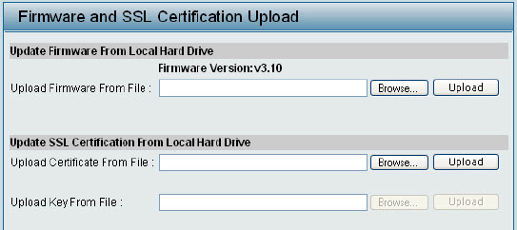

New Features:
Fireware Version | New Features
V3.30 | 1. Remove the “enter” action when login using CLI  2. Support Ethernet in/out traffic for standard MIB  3. Support maximum community string length to 32 characters.
V3.21 | - Add the new flash chip support
V3.20 | - Add Administration VLAN feature  - Add Primary SSID with VLAN tag.  - Add Secondary (backup) Radius Server for WPA (2) Enterprise settings.  - Support Priority by SSID.  - Support Microsoft NAP feature.  - Support IGMP snooping v1/v2.  - Add Rogue AP detection function.  - Support Acct-Interim-Interval attribute for accounting function.  - Add system and wireless sub trap group. User can also enable or disable the  trap categorization.  - Support to administrate AP with WLAN (Default enable).  - Support four management IP range.  - Add CLI command to input SNMP Location.  - Add Ping control setting.  - Add WMM control on each MSSID.  - Support AP Manager II v2.  - Support MSSID over WDS.  - Support IAPP.  - Add wireless station linkup and link down trap.

Changes of MIB & D-View Module:
None

Problems Fixed:
Firmware Version | Problems Fixed
V3.30 | 1. Can’t get WDS RSSI from MIB
V3.21 | None
V3.20 | - User will fail to login to the management web UI via IE 7.0 if silverlight was installed.  - MSSID will be modified if primary SSID security is set to 802.1x.  - When change primary SSID settings, sometimes MSSID will also be changed.

Known Issues:
Firmware Version | Known Issues
V3.30 | None
V3.21 | None
V3.20 | None

Related Documentation:
- DWL-2700AP User Manual v3.20

