DWL-AG660

Date: March 15, 2004

Product name: | 802.11a/g Wireless Cardbus Adapter
Product Group & Type:
Revision: | B1
Available:
Picture: | 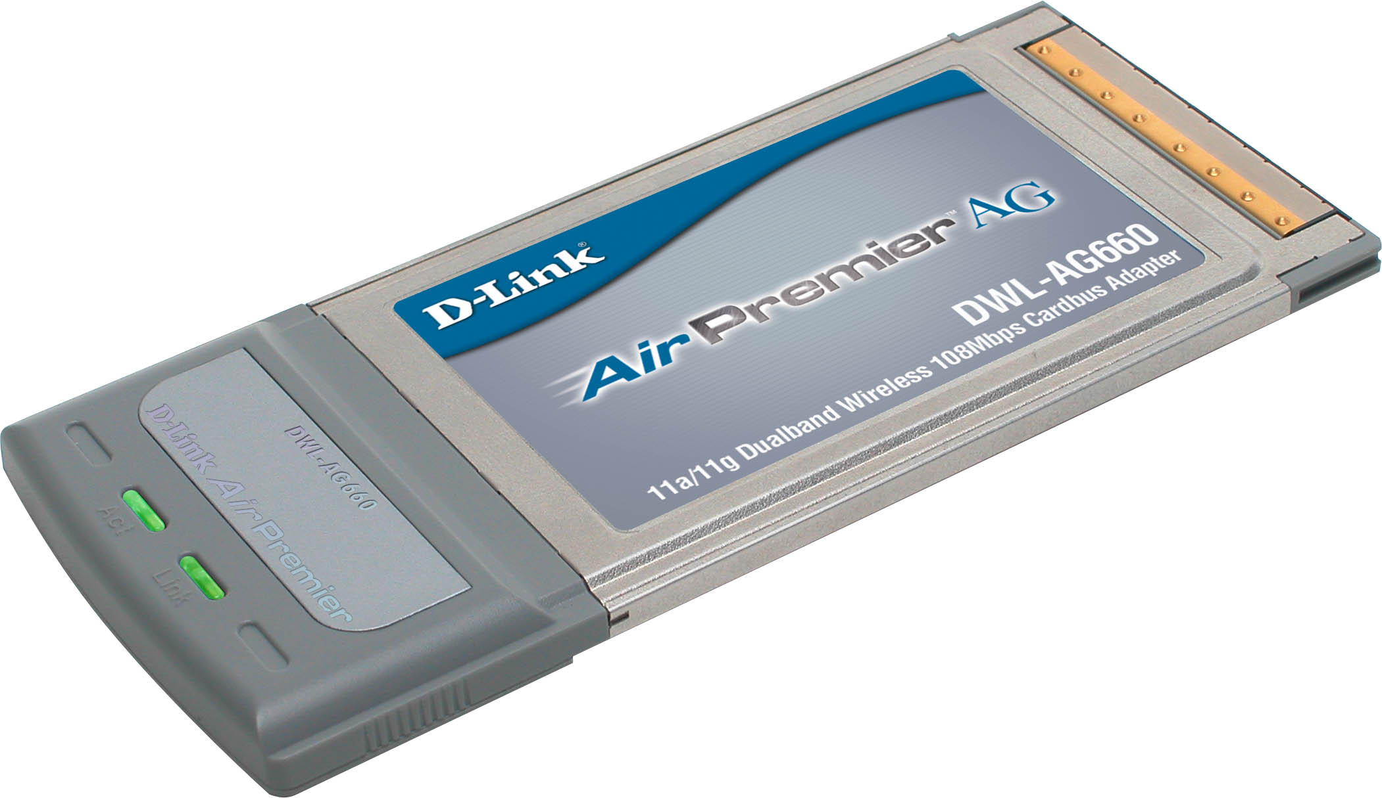
Why Sell This Product: | - Super AG 108Mbps high speed dualband. This DWL-AG660 adapter will eventually replace the current DWL-AG650 adapter that supports only 54Mbps speed. The DWL-AG660's Super AG 108Mbps speed is provided by means of a software driver provided on the CD.  Selling Points  - Same price as DWL-AG650 but has higher speed.  - Tri-mode a/b/g, dualband wireless.  - Advanced security with WPA, 802.1x authentication, TKIP and Pre-Shared Key function support.
Keyfeatures: | - 802.11a/g industry standard  - Dual 5GHz and 2.4GHz frequency bands  - Up to 108Mbps (Turbo mode) network data transfer rate on both frequency bands, 15 times faster than 802.11b  - Strong 64/128/152-bit WEP data encryption security  - Compatible with existing 802.11b wireless devices  - Advanced security with WPA, 802.1x authentication, TKIP and Pre-Shared Key function support  - Powerful integrated antenna provides 100-meter indoor,  - 400-meter outdoor operation range *  - Runs Windows 98 SE, 2000, ME, XP  * Environmental factors may adversely affect range.
Technical Details: | System Requirements  - Laptop with available CardBus Type II slot  - Windows XP, 2000, ME or 98 SE  - 300MHz CPU or above  - 32MB memory or more  Standards  - IEEE 802.11a  - IEEE 802.11b  - IEEE 802.11g  PC Card Standard & Interface  PC Card Type II CardBus 32-bit compliant  Media Access Control  CSMA/CA with ACK  Data Rates  (With automatic fallback)  54Mbps, 48Mbps, 36Mbps, 24Mbps, 18Mbps, 12Mbps, 11Mbps,  9Mbps, 6Mbps, 5.5Mbps, 2Mbps, 1Mbps  Modulation Technology  - Orthogonal Frequency Division Multiplexing (OFDM)  - Complementary Code Keying (CCK)  - Direct Sequence Spread Spectrum (DSSS)  Frequency Range *  - 2.4GHz to 2.5GHz  - 5.15GHz to 5.875GHz  * Software configurable as allowable frequency will vary from country to country in the European region.  Transmit Output Power  - 802.11a:  +10 to 14dBm @ 54Mbps  +11 to 15dBm @t 48Mbps  +13 to 15dBm @t 36Mbps  +17 to 18dBm @ 24, 18, 12, 9 and 6Mbps  - 802.11b:  +18dBm @ 11, 5.5, 2, and 1Mbps  - 802.11g:  +10 to 14dBm @ 54Mbps  +11 to 15dBm @ 48Mbps  +13 to 15dBm @ 36Mbps  +17 to 18dBm @ 24, 18, 12, 9 and 6Mbps  Receive Sensitivity  - 802.11a (@ 10% PER):  87dBm for 6Mbps  86dBm for 9Mbps  85dBm for 12Mbps  83dBm for 18Mbps  80dBm for 24Mbps  76dBm for 36Mbps  71dBm for 48Mbps  66dBm for 54Mbps  73dBm for 108Mbps (Turbo Mode)  - 802.11b (@ 8% PER):  84dBm for 11Mbps  90dBm for 2Mbps  - 802.11g (@ 10% PER):  87dBm for 6Mbps  86dBm for 9Mbps  85dBm for 12Mbps  83dBm for 18Mbps  80dBm for 24Mbps  76dBm for 36Mbps  71dBm for 48Mbps  66dBm for 54Mbps  Antenna  2dBi to 4dBi Gain integrated antenna  Operation Range  - Indoors: up to 100 meters *  - Outdoors: up to 400 meters *  * Environmental factors may adversely affect range.  Security  - 64/128/152-bit WEP data encryption  - 802.1x authentication  - WPA (Wi-Fi TM Protected Access): 802.1x, Pre Share Key, WEP, TKIP, AES  Physical & Environmental  LED Indicators  - Power  - Network  Operating Voltage  5 VDC +/- 10%  Power Consumption  - Transmit mode: 1947mW  - Receive mode: 1056mW  - Sleep mode: 40mW  Dimensions  118 (L) x 53 (W) x 5 (H) mm (including antenna)  84 (L) x 53 (W) x 3 (H) mm (adapter only)  Weight  41grams (adapter including antenna)  Operating Temperature  0 to 45 °C  Storage Temperature  -10 to 60 °C  Humidity  95% maximum (non-condensing)  EMI Certification  - FCC Class B  - CE Class B  O.S. Support  Windows 98 SE, ME, 2000, XP
EMI/EMC Report | ☑FCC No. ☑ CE No. ◻ VCCI No.  ◻ CTR-21 No. ☑ C-Tick No. ACN052202838 ◻ A-Tick No.  ◻ FDA No. ◻ R&TTE No. ◻ BSMI No.  ◻ Others
Safety | ◻ TUV No. ◻ UL No. ◻ CSA No.  ◻ Others
Packaging Style | ◻ Clamshell ◻ White Box ☑ Gift Box ◻ Bulk ◻ Others
Packaging Contents: | 1. DWL-AG660 wireless Cardbus Adapter  2. Driver and Manual on CD-ROM  3. Quick Installation Guide
UPC Code:
  DWLAG660EUB1  790069 265228 | DWLAG660FRB1  790069 265235 | DWLAG660SGB1  790069 265242
  DWLAG660AUB1  790069 265259 | DWLAG660LAB1  790069 265266 | TDWLAG660.B1  790069 265280
Units Per Carton: | 40
Cartons Per Pallet: | Air: 18, Sea: 30
Dimensions and Weight: | Box: 237 x 170 x 35 mm, 0.35 kg  Carton: 385 x 352 x 502 mm, 17.7 kg  Pallet: (by Air) 1200 x 1100 x 1260 mm, 274 kg  (by Sea) 1200 x 1100 x 2020 mm, 447 kg  INTRASTAT weight: kg (Box)  Packing material weight (Box):  - Paper: kg  - Plastic: kg  - Mixed: kg

