DSB-C120

Date: July 12, 2005

Product Description: | USB1.1 PC Camera
Revision: | A1
Availability: | E/June , 2005
Picture: | 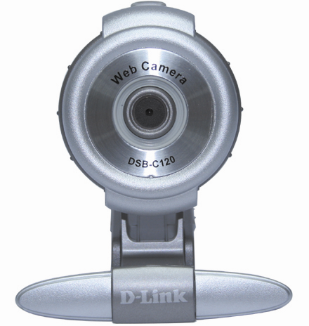
Why Sell This Product: | This DSB-C120 web cam is a cost down version PC camera that will eventually replace the current DSB-C110. It costs less than the DSB-C110 and has a sleek new design, which should be the new style for all our new PC web cams.  Selling Points  - Lower cost.  - 100K pixels.  - Sleek new design, equipped with mount for clipping on top of notebook or desktop computer screen.
Key Features: | Resolution  - 352 x 288 Resolution  - Color CMOS Sensor  - 16.7 Million Color Support  Video Conference  - Video Conference With Microsoft NetMeeting  - Video Conference 1-On-1 or With a Group  Still Image  - Flicker-Free Still Image Capture  - Snapshot Switch to Take Photos  Bundled Software  - VP Eye 4.0 Video & Photo Editing Software I Included  Computer Connection  - USB Connection to PC  - Mount for Clipping on Laptop Computer or Monitor Screen  Sleek Design  - Available in Three Different Colors
Technical Details: | Sensor  1/4 inch CMOS  Resolution  100K pixels (352 x 288)  Lens  F/2.8 aperture  Focus Length  Manual focus 10cm to infinity  Image Enhancement Control  - Brightness  - Contrast  - Gamma  - Saturation  - Sharpness  Exposure  - Automatic optical exposure  - Automatic white balance and gain control  Image Performance Enhancement  Data compression supported  Video Software Functions  - Video conferencing  - Still image capture  - Personal security system  Host Interface  - USB 1.1  - Standard USB Type A interface with hot plug-in/out  - Powered from USB interface, no external power adapter required  Performance  - 30 fps @ QQVGA (160 x 120)  - 30 fps @ QVGA (320 x 240)  Light Control  Automatic exposure  Display Color  24-bit true RGB color  Minimum Luminance  25 Lux  System Requirements  - Pentium III 500MHz, Celeron, AMD Athlon processor or higher  - 64MB RAM (or minimum OS requirement, whichever is higher)  - 200MB free hard drive space  - Microsoft Windows XP/2000/ME/98SE  - CD-ROM drive  - DirectX 8.1b and above  - Update Service Pack  - USB port (1.1 or higher)  - 24-bit color display adapter  - Windows compatible sound card and speakers (full duplex sound card recommended)  Additional Hardware Requirements for Video-conferencing and Video Mail  - 16-bit sound card or better  - Speaker  - Microphone  - 56Kbps modem or DSL/cable modem  Power Supply  USB bus powered  Power Consumption  Less than 0.75 watts (full operation)  Emission  - FCC Class B  - CE  - C-Tick
EMI/EMC Report | ☑FCC No: ☑ CE No ◻ VCCI No. ◻ CTR-21 No. . ◻C-Tick No. ◻ A-Tick No.  ◻ FDA No. ◻ R&TTE No. ◻ BSMI No.  ◻ IC No. ◻ Others
Safety | ◻ TUV No. ◻ UL No. ◻ CSA No.  ◻ Others
Packaging Style | ◻ Clamshell ◻ White Box ☑ Gift Box ◻ Bulk ◻ Brown Box ◻ Others
Packaging Contents: | - DSB-C120 PC Camera *1  - USB 1.1 Cable * 1 (1.5m)  - CD * 1  - Quick Installation Guide *1
UPC Code:
  UPC code |  | Part Number
  790069 | 284823 | ISBC120BL.A1
  790069 | 284830 | ISBC120S..A1
  790069 | 284847 | ISBC120W..A1
Units Per Carton: | For USA | For EU | For WW
Units Per Carton: | 20 | 20 | 20
Cartons Per Pallet: | For USA | For EU | For WW
Cartons Per Pallet: | Air:32, Sea: 48 | Air:48, Sea: 48 | Air:24, Sea: 40
Dimensions and Weight: | Box:  ◻ 237x168x36mm (Type A) ◻ 225x150x75mm (Type B)  ◻ 269x162x65mm (Type C) ◻ 274x208x68mm (Type D)  ◻ 274x208x118mm (Type D1) ◻274x208x138mm (Type D2)  ◻ 288x245x66mm (Type E)  , Others ____233x148x56 (Type B1) , 0.26 kg  Carton: 476 x 240 x 320 mm, 6.2 kg  Pallet: (by Air) 1220 x 1020 x 1415 mm, 198.4 kg (for USA)  1200 x 1100 x 2070 mm, 297.6 kg (for EU)  1200 x 1100 x 1095 mm, 148.8 kg (for WW)  (by Sea) 1220x1020x2055 mm, 297.6 kg (for USA)  1200x1100x2070 mm, 297.6 kg (for EU)  1200x1100x1735 mm, 248 kg (for WW)  INTRASTAT weight: 0.221 kg (Box)  Packing material weight (Box):  - Paper: 0.2314 kg  - Plastic: 0.0024 kg  - Mixed: 0.0046 kg

